1. Introduction
2. Overall Description
3. Specific Requirements
   1. Functional Requirements
   2. Non-Functional Requirements
4. Data Model Description
5. Conclusion

Functional Requirements

A license plate recognition system needs a few key components to function properly. These involve gathering photos, pre-processing them, finding plates, segmenting characters, recognizing characters, post-processing them, and archiving the outcomes. Each of these components is crucial for the system to effectively identify license plates in a certain image or video frame. To improve the accuracy and efficacy of the recognition process, machine learning techniques are typically applied as well. Also, the system must be able to adapt to a wide range of environmental circumstances, including changing lighting conditions, fluctuating weather, and different license plate angles. The efficiency of an LPR system ultimately depends on the implementation of these components and the precision of the machine learning algorithms.

**Process**

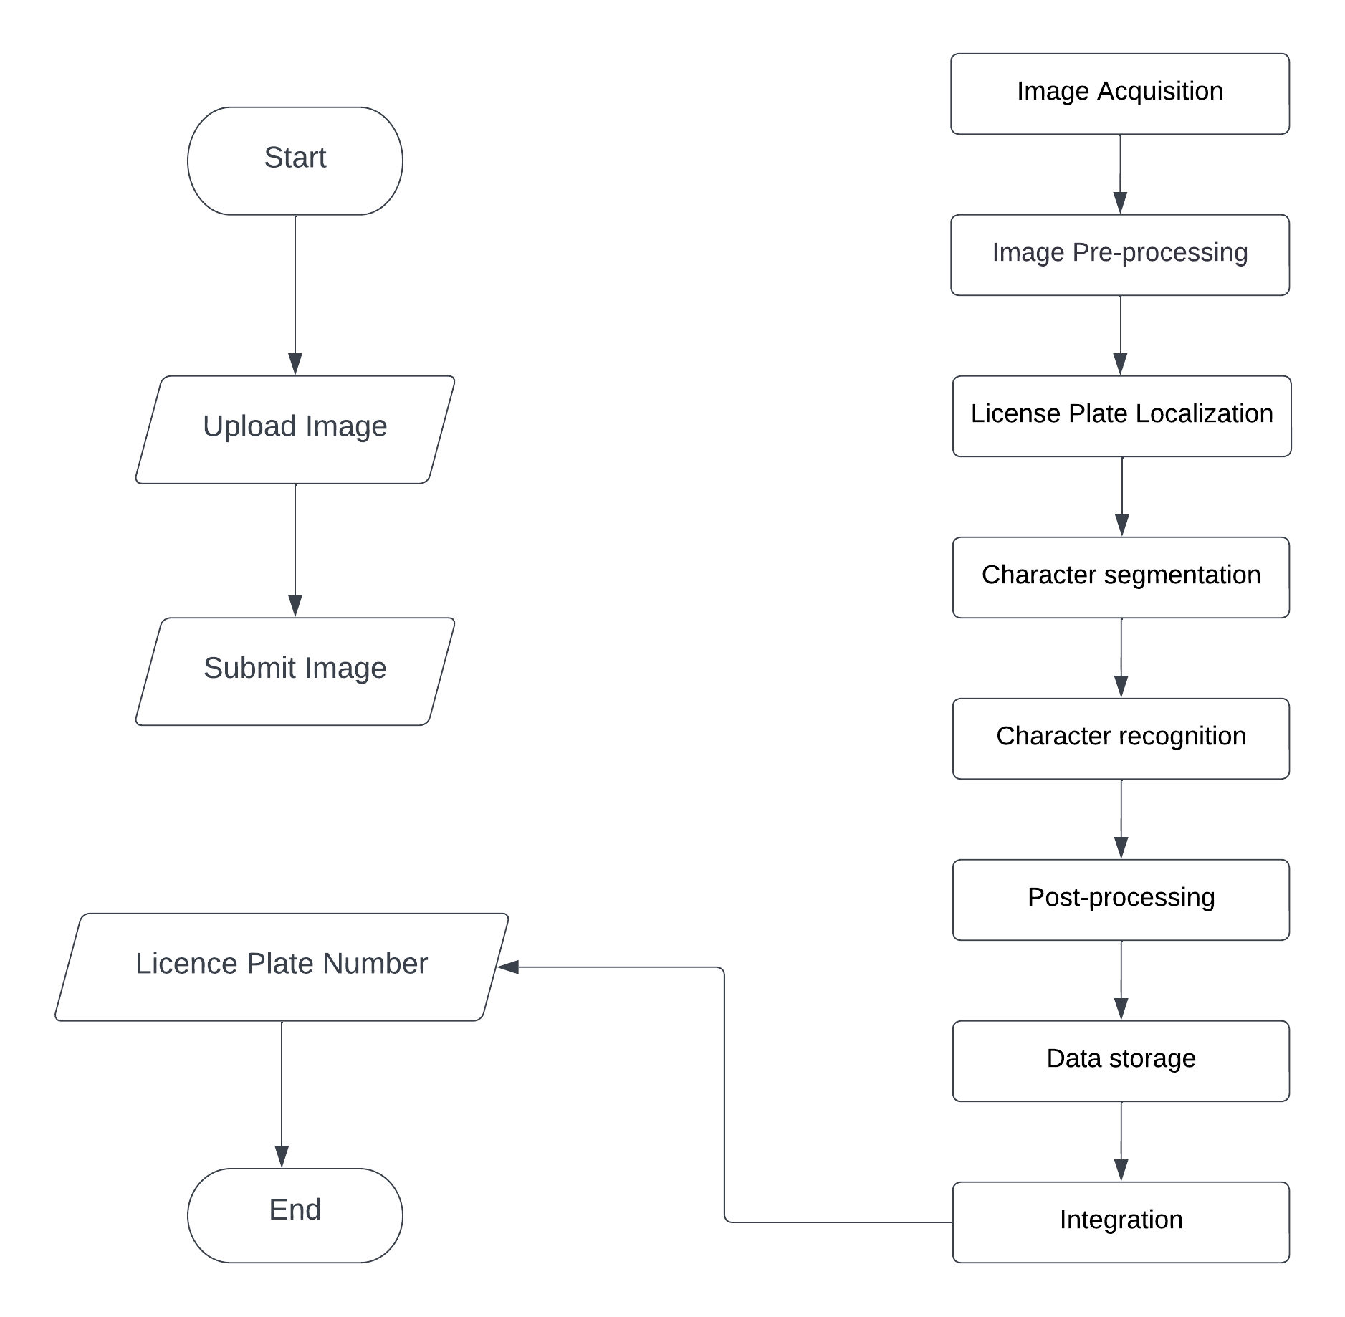

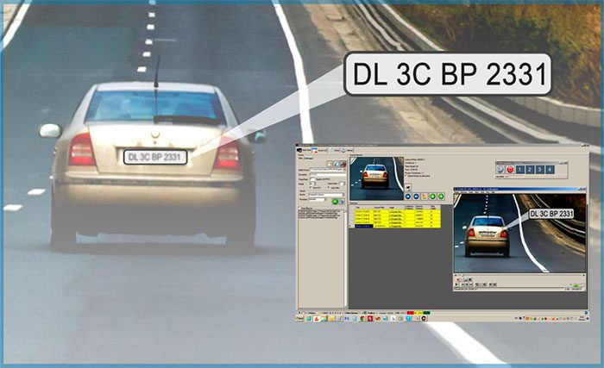

1. Image Acquisition

The process of acquiring digital images from various devices, including cameras, scanners, and files, is known as image acquisition. Image collection is a vital step in the identification of license plates since it impacts the precision and efficacy of the subsequent processing operations. While gathering photos for license plate identification, there are a number of things to take into account. They include the image resolution, image format, illumination, and camera angle. It is crucial to take high-quality pictures with consistent illumination and a good view of the license plate in order to guarantee correct recognition.

These are a few illustrations of picture acquisition methods used for license plate recognition: video cameras, still cameras, mobile devices, and scanners. For real-time license plate recognition in traffic control systems, videos are frequently used. They can produce a continuous stream of data that can be analyzed in real-time and can take several photos per second. Still cameras can be used to take pictures of moving vehicles, as well as of moving vehicles entering or leaving a parking lot. To leverage license plate photos for applications like parking management or law enforcement, mobile devices like smartphones or tablets can be employed. Paper papers like registration forms or parking tickets can be scanned to digitize the license plate photos.

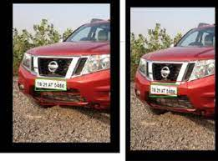

1. Image Pre-processing

An image's quality must be improved through pre-processing to allow for the extraction of essential components that can be used for additional analysis. The further preparation processes are applied to the shot. The zone of interest is predetermined and depends on the surroundings, such as a level, incline, or depressed surface, where the device is being used. The region of interest is trimmed and turned to grayscale to quicken processing and streamline the method. The edges are then enhanced to stand out more. When a picture is converted from RGB to greyscale, some important details, such as color contrast, lighter object edges, etc., could be lost. Those losses are cancelled out by dilation, which also improves the edges.

For pre-processing license plate photos, a variety of methods are available, such as image scaling and cropping, image filtering, image thresholding, and image normalization.

Image scaling and cropping are Image resizing and cropping to a uniform size and aspect ratio can enhance uniformity and speed up processing. To concentrate on the license plate, it can also be helpful to crop off unnecessary portions of the image. Image filtering methods like median filtering or Gaussian filtering can be used to reduce noise and enhance the edges and details in the license plate area. The process of image thresholding can convert a grayscale image into a binary image by designating pixels as either white or black depending on a threshold value. As a result, the contrast and sharpness of the license plate might be enhanced. Image normalizing techniques can be used to alter the brightness, contrast, and color space of the image for reliable feature extraction and recognition.

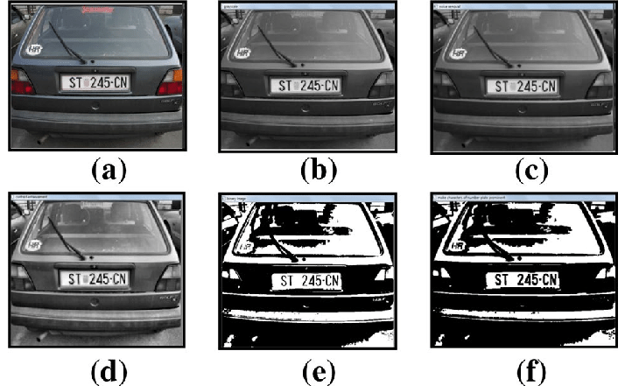

1. License Plate Localization

Plate localization, which involves identifying the license plate region in an image or video frame, is an important step in license plate recognition systems. The goal is to isolate the license plate area from the image's background so that further processing can be performed to recover the plate's characters.

Edge detection, morphological processing, template matching, and deep learning are methods for finding license plates. Edge detection algorithms can be used to identify the license plate's edges in order to create a bounding box around it. Morphological processes like dilatation and erosion can benefit the plate's edges and lower image noise. The plate could be located utilizing template matching methods and a recognized pattern or template. Using deep learning techniques like object recognition and segmentation, the license plate region in the image may be located and identified.

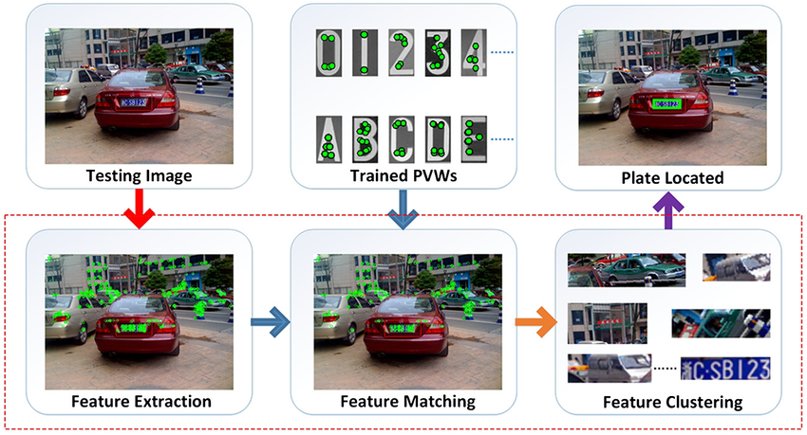

1. Character segmentation

In license plate recognition systems, character segmentation is an essential stage. It entails removing specific characters from a picture of a license plate. In order to make it simpler for a character recognition algorithm to recognize and categorize the characters, it is intended to segregate the characters from one another and from the background. Character segmentation can be done using a variety of methods, such as thresholding, edge detection, linked component analysis, and template matching.

One of the most basic methods for character segmentation is thresholding. For the foreground characters to be distinguished from the background, a threshold value must be set. Another method for determining the boundaries of the characters is edge detection. A more sophisticated technique called connected component analysis divides pixels into regions that correspond to particular characters by grouping pixels with comparable properties. To recognize and isolate the characters on the license plate, template matching entails comparing the image to a set of pre-defined templates of characters.

Although these methods exist, character segmentation can be challenging because to variations in font sizes, styles, and location on the license plate. Moreover, license plate photographs may contain a variety of noise, such as reflections, shadows, and blurring, which might complicate the character segmentation process. Even with these challenges, accurate character segmentation is necessary for license plate recognition systems to achieve high recognition rates. As a result, researchers keep looking into cutting-edge character segmentation approaches, like those based on machine learning and deep learning, to improve the process' accuracy and efficacy.

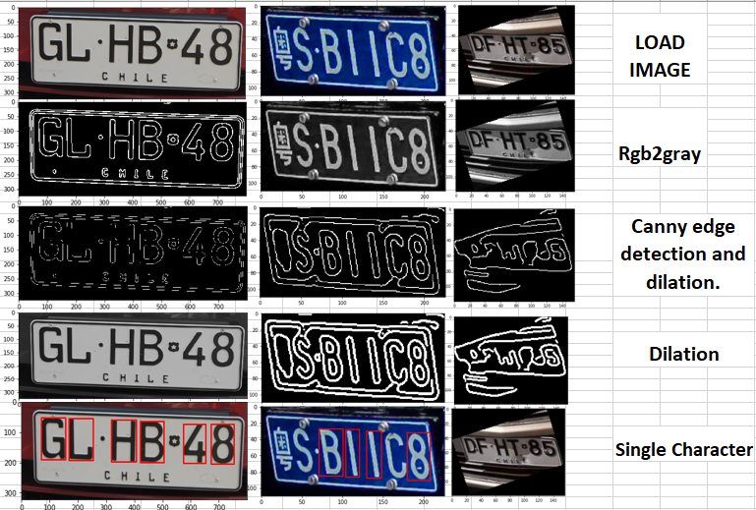

1. Character recognition

Character identification, commonly known as optical character recognition (OCR), is the technique of automatically identifying characters in a picture and turning them into machine-readable text. This is an essential step in the license plate recognition (LPR) process since it enables the extraction of the license plate number from the segmented characters.

Character recognition uses a variety of methods, such as feature extraction, machine learning algorithms like neural networks, template matching, and template matching. In order to determine which character a segmented character belongs to, comparisons against a set of previously created templates are required. The segmented character's lines and curves are used to uniquely identify it. A model that has been trained on a huge dataset of characters can be used using machine learning techniques to recognize new characters.

One of character recognition's challenges is dealing with variations in font, size, and orientation. Techniques like the scale-invariant feature transform (SIFT) and the rotation-invariant feature transform (RIFT) may be used to get around these issues. Post-processing techniques like context-based recognition and error correction can also be used to improve the accuracy of the recognition.

Generally, Character recognition is a crucial step in the identification of license plates in general. However it has a variety of tactics and challenges. Machine learning and computer vision advancements have made character recognition algorithms more precise and efficient.

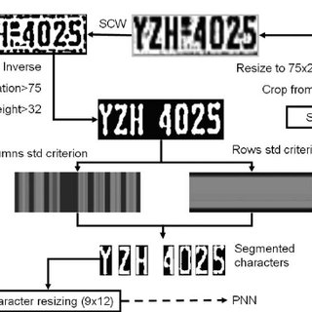

1. Post-processing

Post-processing is a crucial stage in the process of correctly recognizing license plates using machine learning. Character identification and segmentation findings must be honed in this step in order to produce a final output that is accurate and fault-free. Post-processing must include error correction. Errors in character segmentation or recognition can occur, and if you want trustworthy results, you must repair them. There are numerous ways to accomplish this, including context-based error correction, dictionary-based error correction, and rule-based error correction.

Post-processing is not complete without character grouping. It could be essential to combine the characters discovered in the previous step in order to make a complete license plate number. This is important since spaces aren't normally utilized to separate the characters in a license plate number. Using techniques like horizontal and vertical projection, the characters can be organized.

Moreover, post-processing includes checking that the recognized license plate number is actually on the plate. This is accomplished by comparing the number to a list of legitimate license plate numbers for the specified area. This makes sure that only valid results are returned, reducing the likelihood of false positives. Overall, post-processing is a crucial stage in license plate recognition utilizing machine learning and is essential for guaranteeing accurate and trustworthy results.

1. Data storage

Data storage is essential to the operation of systems for recognizing license plates because it allows for the storing of both the images and the data associated with each license plate. The amount of data that needs to be saved can vary greatly depending on the system's scope, therefore effective storage and retrieval procedures are needed. Normally, license plate recognition systems produce a lot of data, making it difficult to store and retrieve it. So, a successful data storage strategy is essential to the system's success.

The raw photos that the camera captured as well as the license plate data that was retrieved from them are both stored as part of the data storage component. In order to be recovered for processing at a later time, the raw images must be stored effectively and securely. For convenience in retrieval and searching, the extracted license plate data must be saved in a structured format and connected to the associated raw image. The system might also need to keep old data for auditing purposes, which would call for bigger storage capacities.

Using a database management system to store the photos and the derived license plate data is one typical method of data storage. This makes data retrieval and searching efficient. But, other methods of storing, such cloud-based storage, are also an option. The selection of a storage method will be influenced by variables like system needs, financial constraints, and security considerations. Ultimately, a license plate recognition system's effectiveness depends on its ability to manage and retrieve the massive volumes of data created. This is made possible by an efficient data storage method.

1. Integration

Each software development project, particularly those using machine learning-based systems like license plate recognition, must include integration. Integration is the process of joining various system modules or components to produce a finished, functional system. When it comes to real-time license plate recognition, integration entails combining the many system elements—such as picture capture, pre-processing, plate location, character segmentation, and character recognition into a unified system.

To make sure that all of the system's components function together without any problems, integration is a complex process that needs to be carefully planned and carried out. In the case of license plate recognition, integration may entail creating APIs and data transfer protocols that enable real-time communication between various system components. Creating user interfaces and dashboards that let people interact with the system and view its results may also be a part of integration.

Any machine learning-based system must successfully integrate in order for it to operate as intended and produce correct results. As additional parts or modules may be added to the system without impairing its functionality, it also makes system maintenance and scalability easier.

Overall, An LPR system requires accurate picture capture, efficient pre-processing, dependable plate localization, exact character segmentation, and exact character recognition in order to recognize license plates correctly. These functional requirements necessitate the use of powerful computer vision and machine learning methods. The system must also be able to store and manage enormous amounts of data effectively. The LPR system needs to be connected to other systems, such as law enforcement databases, in order to provide useful information and facilitate investigations. Several functional needs must be met in order to guarantee that the LPR system can operate successfully and efficiently in a range of settings, including surveillance, traffic monitoring, and parking management.